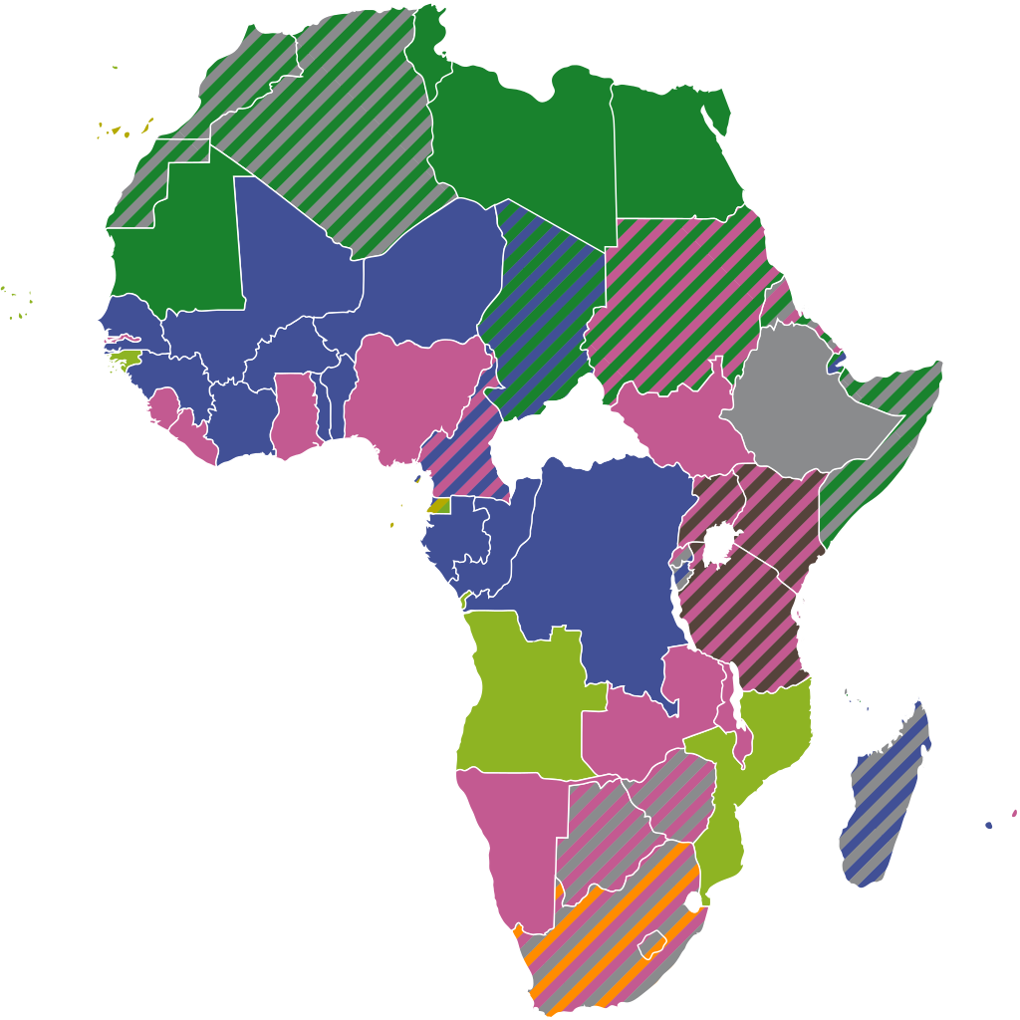

Jambo (Hello) 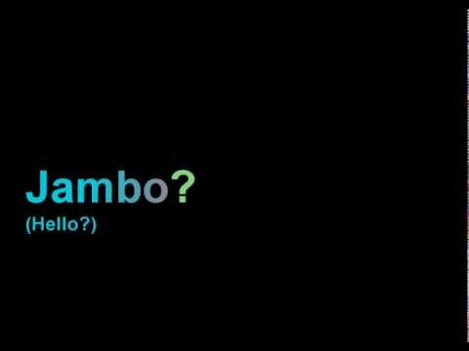 Second Grade Star,
Welcome back to a new and exciting school year. The world is going through a very hard time. We had to make changes in our lives that have not been easy. One change is a new way of going to school. This was something that none of us were ready for. I hope you are staying safe through all of this.

I warmly welcome you all back. This new way of attending school will allow us to take our learning to the stars. This is new for all of us, but we will get through this together. I look forward to the day when we can come back to our classroom.
Nitakuona hivi karibuni (See you soon),
Mwalimu (Teacher) Tsasa

